2121 Final Exam Practice

- Design a Finite State Machine that recognizes all binary strings that does not start with 01 and ends with 010.

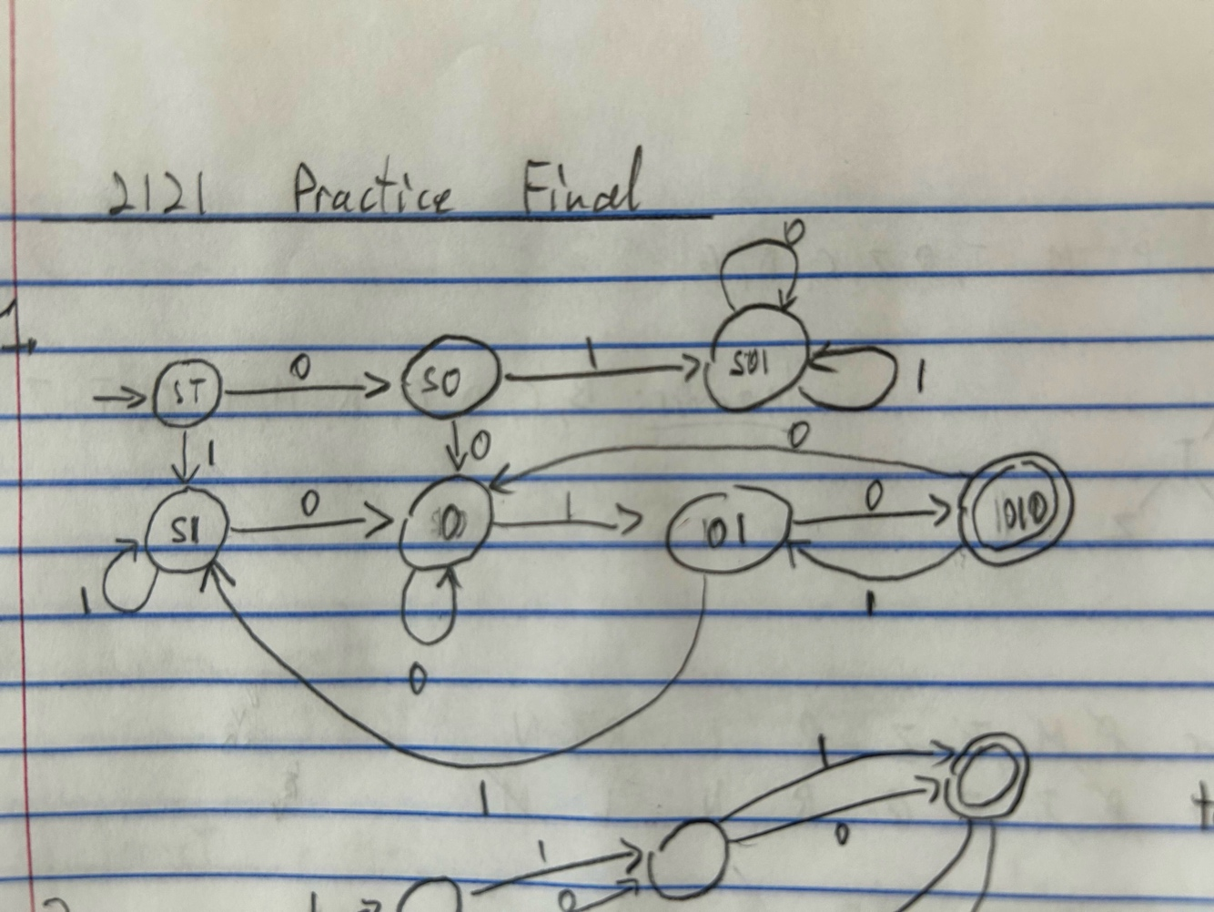

- Recreate the tree from the following In-Order and Post-Order traversal.

Inorder: P M T Z Q L R N
postorder: P T Z Q R N L M

M
/ \
P N
/ / \
Q Z R
/
T

- Prove the following with induction:
$$1^{2}+2^{2}+3^{2}+…+n^{2}=\frac{n\left(n+1\right)\left(2n+1\right)}{6} for n≥1$$

1) Base Case: n=1
LHS: $1^{2}=1$✓

RHS: $\frac{1\left(1+1\right)\left(2\left(1\right)+1\right)}{6}=\frac{1\left(2\right)\left(3\right)}{6}=\frac{6}{6}=1✓$

2) Inductive Hypothesis: n=k

$$1^{2}+2^{2}+3^{2}+…+k^{2}=\frac{k\left(k+1\right)\left(2k+1\right)}{6}$$

3) Target: n=k+1

$$1^{2}+2^{2}+3^{2}+…+k^{2}+{\left(k+1\right)}^{2}=\frac{\left(k+1\right)\left(k+1+1\right)\left(2\left(k+1\right)+1\right)}{6}$$
$$= \frac{\left(k+1\right)\left(k+2\right)\left(2k+3\right)}{6}$$
$$= \frac{1}{6}\left(2k^{3}+9k^{2}+13k+6\right)$$

4) Proof:
LHS:
$$1^{2}+2^{2}+3^{2}+…+k^{2}+{\left(k+1\right)}^{2}$$
Using the inductive hypothesis:
$$\frac{k\left(k+1\right)\left(2k+1\right)}{6}+{\left(k+1\right)}^{2}$$
$$= \frac{1}{6}\left((k^{2}+k)(2k+1)+6{\left(k+1\right)}^{2}\right)$$
$$=\frac{1}{6}\left(2k^{3}+3k^{2}+k+6k^{2}+12k+6\right)$$
$$=\frac{1}{6}\left(2k^{3}+9K^{2}+13k+6\right) Same as target! Proved$$
- Find the resulting tree and the contents of the return stack by performing DFS starting at dfs(1). Iterate through neighbors in increasing order.

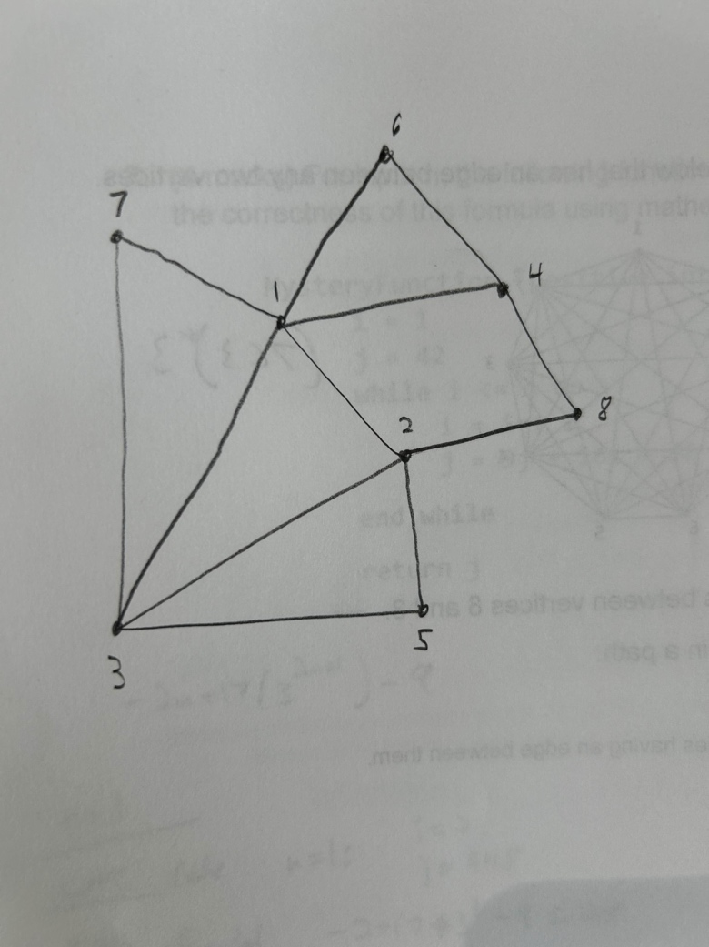

4  4  2  3  3  2  1  ⋂ | 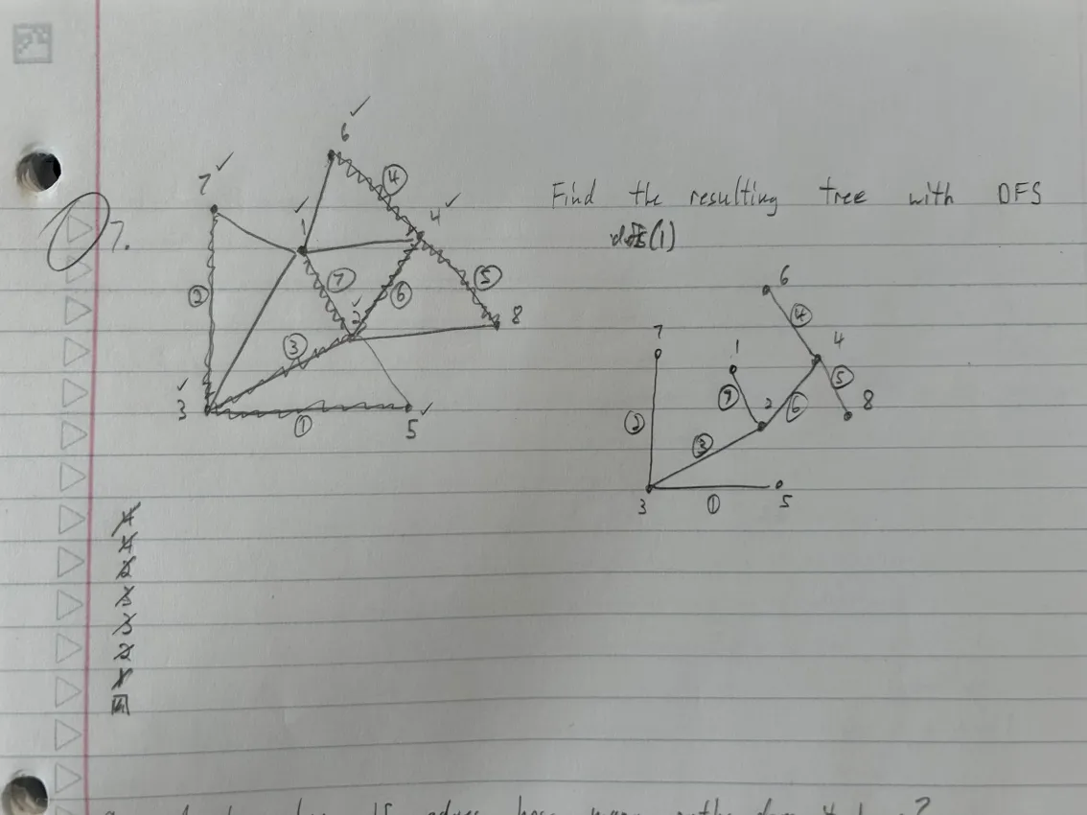 | 

- A tree has 15 edges. How many paths does it have?

$$\left|V\right|=\left|E\right|+1 16 vertices$$
$$\left({16 \atop 2}\right)=\frac{16}{2!14!}=120$$

- Find the value of the variable “counter” after the following segment is executed.
counter = 300
for i = 10; i <= 70; i++
counter = counter + 3(i - 2)
for j = i; j <= 80; j++
counter = counter + 4

$$c=300+\sum_{i=10}^{70}{3\left(i-2\right)}+\sum_{i=10}^{70}{\sum_{j=i}^{80}{4}}$$

$$c=300+3\sum_{i=10}^{70}{i}-6(70-10+1)+4\sum_{i=10}^{70}{(80-i+1)}$$

$$c=300+3\left[\sum_{i=10}^{70}{i}-\sum_{i=1}^{9}{i}\right]-366-4\left[\sum_{i=10}^{70}{i}-\sum_{i=1}^{9}{i}\right]+4\left[81(70-10+1\right]$$

$$c=-66+19764-\left[\frac{70\left(71\right)}{2}-\frac{9\left(10\right)}{2}\right]=17258$$

- Given:
$$\sum_{j=1}^{6}{(13a_{j}​-j+3)}=400 and \sum_{i=1}^{5}{(a_{i}​+2)}=400$$Find $a_{6}$

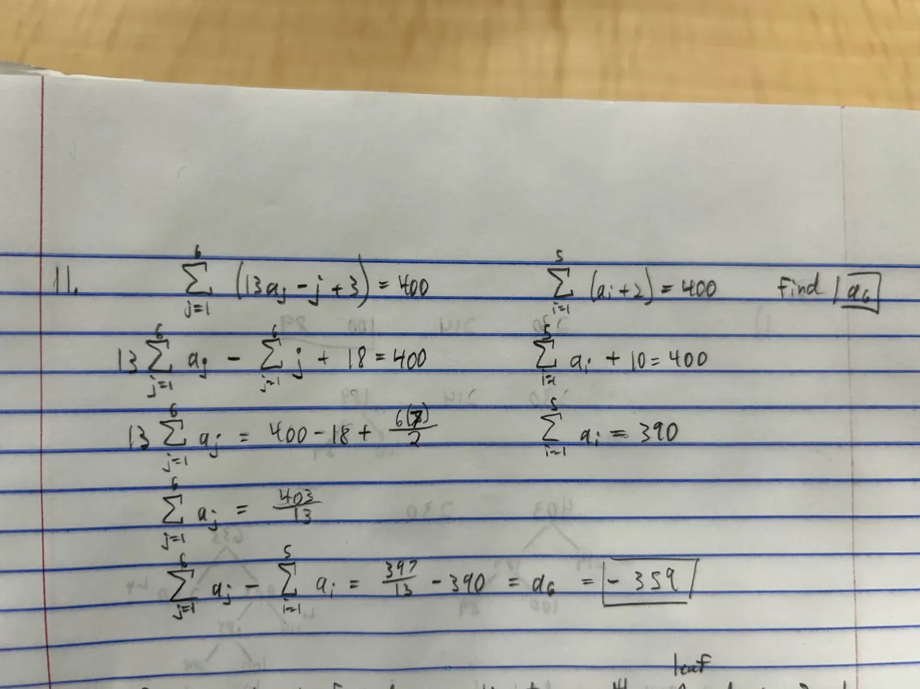

- Prove that the minimum number of nodes on a binary tree with n leaf nodes
is 2n – 1.

Solution Notes:
- Start by drawing some binary trees
  - From this, derive an expression to relate a tree with n leaf nodes to a tree with n+1 leaf nodes
- You should note that if you can prove this for a full binary tree, then this holds true for any non-full tree as well (has fewer leaf nodes and therefore a lower minimum than for a full tree)
- Use this new expression to create a proof by induction with the one given in the question
- The base case, assumption, and target steps are in terms of: x = 2n – 1 (given expression)
  - Substitute this into the expression you derived at leaf nodes = k+1 to perform PBI

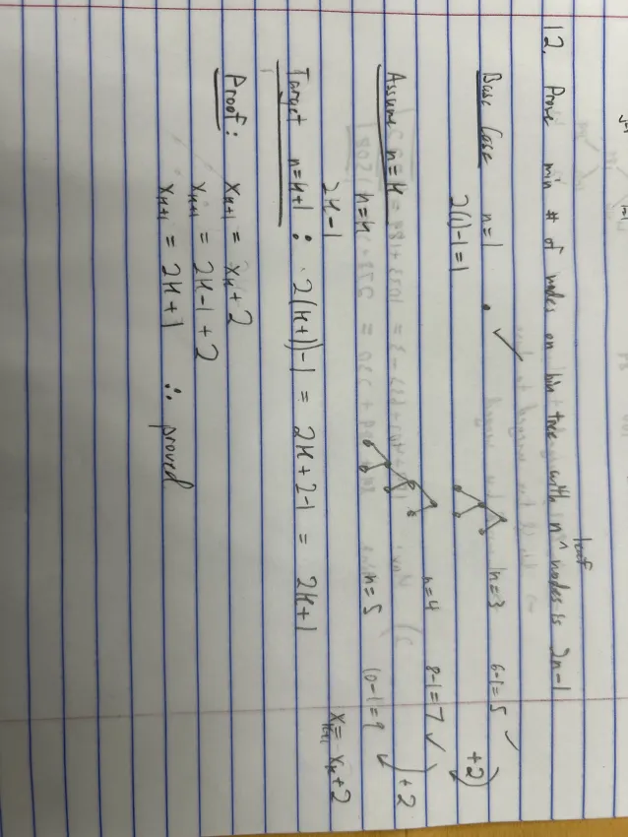

- Given 4 lists sorted in ascending order, find the optimal merge pattern to minimize the total number of needed comparisons with Huffman’s algorithm. Then find the most and least number of comparisons required by the merge pattern.

$$L_{1}:89, L_{2}:100, L_{3}:214, L_{4}:230$$

